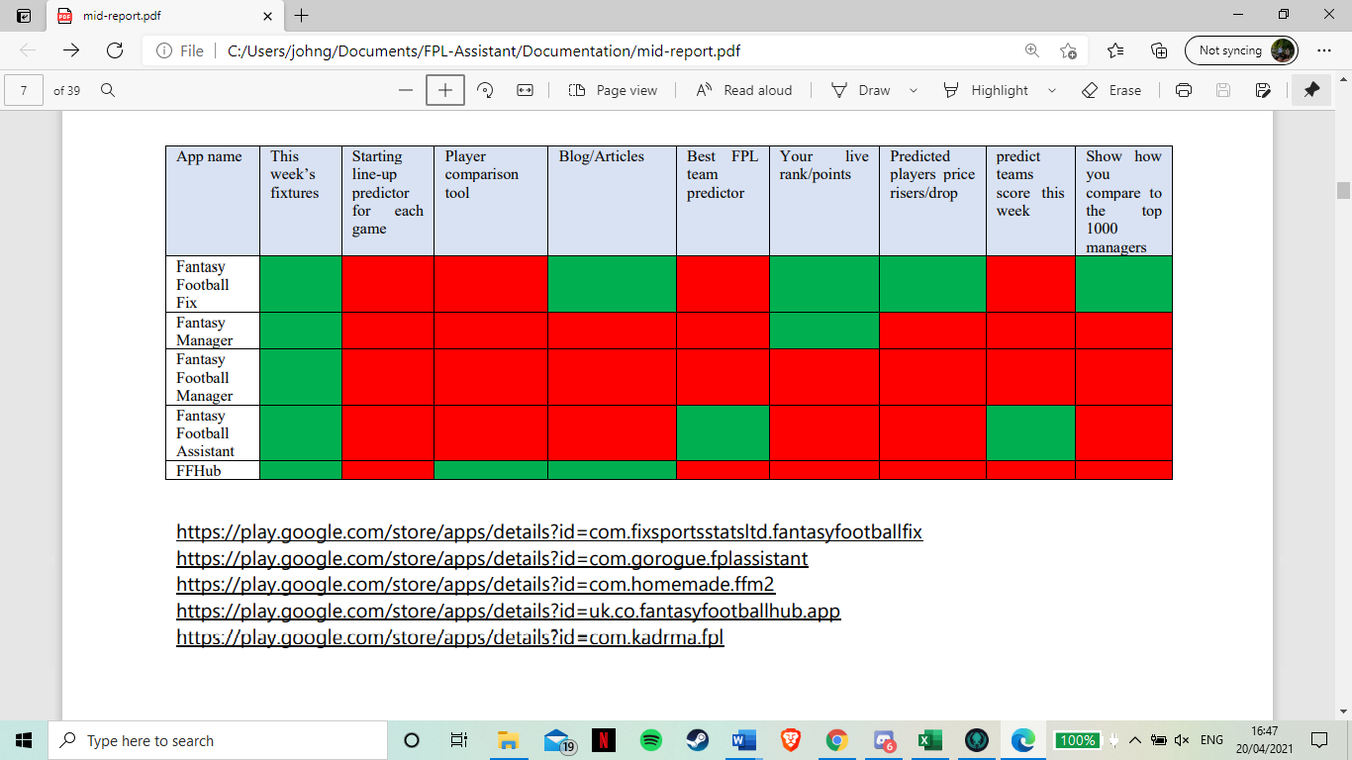**Other FPL Assistant Apps Research**

I downloaded the 5 most downloaded FPL assistant apps on the play store and tested them all

**Fantasy Football Fix**

notes:

- Has a blog

- made me sign into my FPL account

- beat the price rise (who will go up 0.1 today)

- shows the weeks fixtures

- shows your points this week live

- shows how you compare to the top 1000 managers (points this week, live rank)

- Website

Opinion

Overall a nice simple app. I can see the appeal of this app for people who want live information about how their team is doing. For my app I don't see much that would fit what I am going for. My goal is to simplify things for new users and I feel all the live points and how you’re doing compared to the top 1000 players doesn’t offer much help to the user. The aim of this app is for people who want to see how they are doing during the game day instead of waiting for it to update at the end of the day. I do like that it shows the fixtures for the week tough.

**Fantasy Manager**

notes:

- made me sign into FPL - most valuable teams

- Live points - highest scoring leagues

- Summary of game week, highest points, - your current team, with points

how many people used chips, most captained

player

- your points and ranking - this weeks fixtures

- your transfers and available chips - your leagues you’re in and where you are in them

- Highest scoring player each game week - the premier league table

- top transferred in/out players this week - your game week history

- latest injuries

Opinion

Overall I wasn’t a huge fan of this app. I felt that it was just an imitation of FPL app with nothing different. It seems to have the same features and show the same things as the original app. Also it was very cluttered and had an overload of information.

**Fantasy Football Assistant**

notes:

- 5 top projected point scorers this week for each position

- when you click on one it shows more info (e.g in form, lots of people own, being transferred in by a lot of people, owned by a low amount so a hidden gem ect)

- Highest scoring team prediction (with a budget of 100 and with no budget)

- analyse your team, predict score and who to captained

- Shows this week fixtures

Opinions

This was my favorite app that I’ve looked at. Simple, useful features and had stat analysis to make predictions.

**Fantasy Football Manager**

notes:

- make you sign into FPL

- show general (not yours) gameweek 8 stats

- gameweek summary

- top transferred in players

- top transferred out players

- top points player of the past week

- most valuable teams and leagues

- injuries

- your team, and there points, allow transfers

- your leagues

- fixtures

- crashed multiple times when using it

Opinions

This had the same problem as Fantasy Manager. It just seems to be a re-skinned version of the official app with the same features and nothing different.

**FFHub**

notes:

- articles written by writers, only first few paragraphs available before asking to subscribe

- shows fixtures with difficulty but cant do anything without subscribing

- “Stats” can’t access without subscription

- “compare” can’t access without subscription

- array of tools from predictions to looking at the writers teams

Opinions

This is known in the FPL community as one of the best resources when wanting to improve your chance at doing well. Its has a lot of useful features and a lot of stat analysis features. The biggest drawback is that almost all the features are locked behind this paywall.

**Final Thoughts**

I found this research really useful to see what other people had done to assist others at the game. I found that 2 of them didn't actually do anything different, they showed the same things as the official app and offered no features you could do outside it. The main features that appeared often that I liked were:

- showing the fixtures for the week (which the official app already does) but id like to make it so when you click a fixture that it shows the predicted line up

- Being able to compare players (not behind a pay wall and with simpler/better suited stats than the official app)

- An algorithm that predicts the highest scoring team

I also really like the idea of having blog/articles but I want the app to be automated (in the sense of all the features to run automatically with me having to do anything). Possibly look into an API to supply some articles as an option if I have time